Dr. Manrakhan Lal Sahu Govt.College Jamul, Bhilai, Durg.

GREEN AUDIT REPORT
SESSION 2024-25
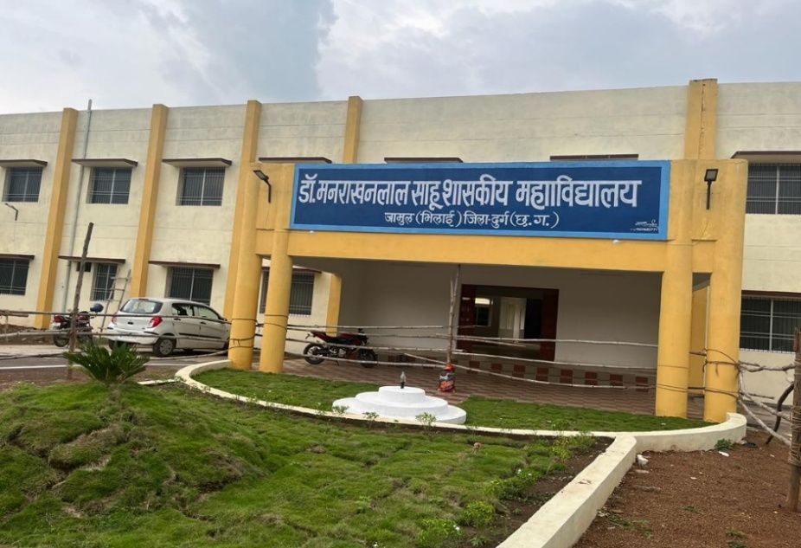

SUBMITTED BY -
Dr. Ramesh Meshram
Shri Gajendra Kashyap
Dr. Rachana Choudhary
GREEN AUDIT REPORT
OF
DR. MANRAKHAN LAL SAHU GOVERNMENT COLLEGE JAMUL, BHILAI DURG, CHHTTISHGARH
Academic Year: 2024-25

A Green Audit is a systematic examination of an institution’s environmental practices and sustainability initiatives. It helps in assessing how effectively a college utilizes natural resources and promotes environmental responsibility. Higher education institutions are encouraged to adopt eco-friendly measures to minimize environmental impact and create a sustainable campus.
The excessive environmental degradation is creating the “Environmental poverty”. Thus, academic leaders should initiate the knowledge and benefits of resources so that their institutions respond to environmental issues and challenges. We believe that there is an urgent need to address these problems and reverse the trends of environment degradation.
The present Green Audit report evaluates the environmental performance of the college with respect to energy use, water management, waste disposal, green initiatives, and environmental awareness.
Our college is spread over an area of ​​22 acres, of which 18 acres, excluding the college building, remain vacant. On this vacant land, saplings have been planted in two phases across 2 acres each, under the Miyawaki plantation initiative by the ICICI Foundation.
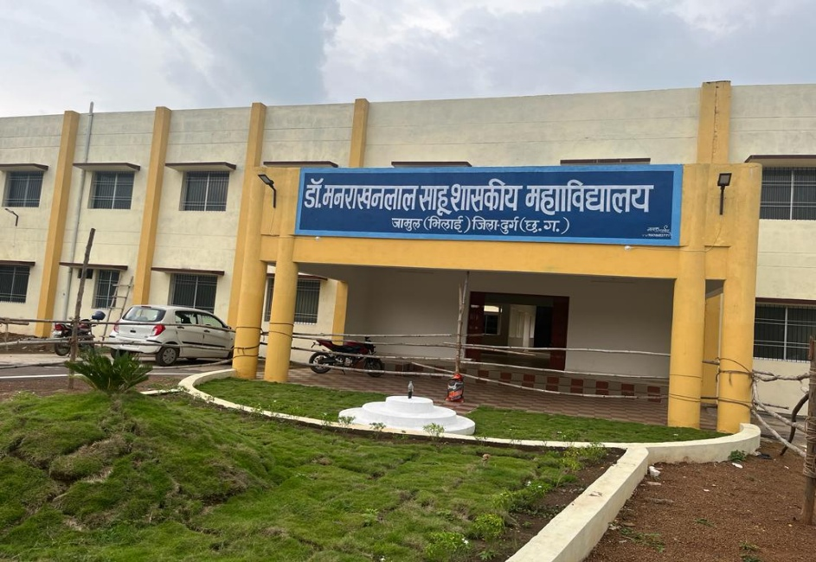

I. Energy Audit Report
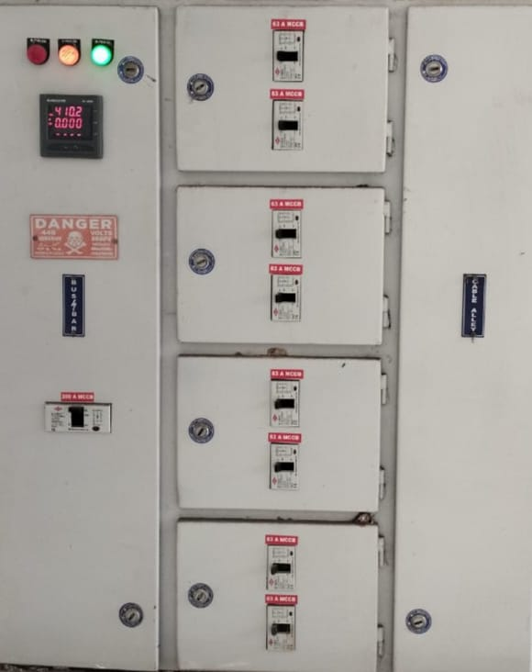

1. Introduction
Energy Audit is a systematic approach to study and analyse the pattern of energy consumption in an institution. The purpose of this audit is to ensure optimum utilization of energy, identify wastage, and recommend measures for energy conservation.
This Energy Audit Report of Dr. Manrakhan Lal Sahu Government College, Jamul, Bhilai has been prepared in accordance with NAAC Criterion 7.1.6, which focuses on quality audits on environment and energy sustainability initiatives undertaken by the institution.
2. Objectives of the Energy Audit
The major objectives of this energy audit are:
- To assess the overall energy consumption pattern of the college
- To identify major areas of energy usage
- To suggest energy conservation measures
- To reduce energy cost and carbon footprint
- To promote sustainable and eco-friendly practices in the campus
3. Scope of the Energy Audit
Particulars | Details
Audit Area | Entire college campus
Buildings Covered | Academic Blocks, Laboratories, Office, Library
Energy Source | Electricity from State Electricity Board
Audit Period | 2024-25
Type of Audit | Preliminary Energy Audit

4. Methodology Adopted
The following methodology was adopted for conducting the energy audit:
- Collection of electricity bills for the last 12 months
- Physical inspection of electrical installations
- Identification of energy-consuming equipment
- Analysis of energy consumption data
- Recommendation of energy conservation measures

5. Energy Consumption Details
5.1 Electricity Consumption
Description | Details
Average Monthly Consumption | 770 Units
Annual Electricity Consumption | 9240 Units
Average Monthly Electricity Bill | ₹ 9240/-
Annual Electricity Expenditure | ₹ 164444.16/-

5.2 Major Energy Consuming Areas
- Classrooms (lighting and fans)
- Laboratories
- Administrative offices
- Library
- Water pumps
- Outdoor and corridor lighting
6. Existing Energy Efficiency Measures
- Use of LED lights in classrooms and corridors
- Natural ventilation and daylight utilization
- Switching off electrical equipment when not in use
- Awareness among students and staff regarding energy conservation

7. Findings of the Energy Audit
- Lighting accounts for a major share of electricity consumption
- Peak electricity usage observed during working hours
- Most electrical appliances are in good working condition
- Scope for further replacement of conventional lights with LEDs

8. Energy Conservation Opportunities
8.1 No-Cost / Low-Cost Measures
- Strict “Switch Off” policy after working hours
- Maximum utilization of daylight
- Regular maintenance of electrical equipment
- Awareness programs on energy conservation

8.2 Long-Term Measures
- Installation of solar photovoltaic panels
- Use of motion sensor-based lighting systems
- Replacement of old electrical equipment with energy-efficient models

S.No | Name of connections | Service number | Contract demand in watt | Tariff category
1 | Dr. Manrakhan Lal Sahu Government College, Jamul, Bhilai | 1009191330 | 35.00 K | LV2ND3SG25

Analysis of billings of meters of college premises
2024-25 | S.C No | Contract demand in kilowatt | Average unit in per month
2024-25 | BP No. 1009191330 | 35 kilo watt | 770

Segment | Electrical Equipment | Wattage | Quantity | Total load in Watt
Lighting | LED TL | 20 | 376 | 7520
Lighting | LED Street Light | 36 | 24 | 864
Lighting | LED Bulb | 15 | 19 | 285
Lighting | LED Panal Light | 15 | 16 | 240
Lighting | Total Lighting Load |  |  | 8909
HVAC | Ceiling Fan | 80 | 201 | 16080
HVAC | Cooler 18'' | 300 | 5 | 1500
HVAC | Exhaust Fan 12'' | 150 | 12 | 1800
HVAC | Air Conditioner 1.5 T | 27 | 2 | 54
HVAC | Total HVAC Load |  |  | 19434
Office Equipment | Computer | 100 | 30 | 3000
Office Equipment | Printer | 55 | 4 | 220
Office Equipment | Photocopy Machine | 600 | 1 | 600
Office Equipment | Total office Equipment Load |  |  | 3820
Water Supply | Pump | 750 | 1 | 750
Water Supply | Total water supply Load |  |  | 750
Other Connection | Water Cooler small | 300 | 1 | 300
Other Connection | Water Cooler Big | 600 | 1 | 600
Other Connection | Smart Board | 150 | 1 | 150
Other Connection | Total other Connection Load |  |  | 1050
Total Connected Load in Watt |  |  |  | 33963
total Connected Load in kilo Watt |  |  |  | 339.63

Segment wise connected load and their percentage
Segment | Total load in Kilo Watt | Load in Percentage
Lighting | 8.909 | 27%
HVAC | 19.434 | 58%
Office Equipment | 3.28 | 10%
Water Supply | 0.75 | 2%
Other Connection | 1.05 | 3%

Total connected load in college (Dr. Manrakhan Lal Sahu Government College, Jamul, Bhilai) -35kw

MONTH | UNITS | ENERGY CHARGE | FIXED CHARGE | METER RENT | FCA | LT/WT CHARGE | TOTAL BILL
APRIL | 870 | 6568.5 | 11200 | 100 | 538.16 | 213.2 | 18193.46
MAY | 570 | 4303.5 | 11200 | 100 | 605.62 | 199.5 | 16408.62
JUNE | 570 | 4417.5 | 11200 | 100 | 391.62 | 0 | 16109.12
JULY | 750 | 5812.5 | 5600 | 100 | 30.48 | 116.86 | 11659.84
AUGUST | 690 | 5347.5 | 5600 | 100 | 274.35 | 0 | 11321.85
SEPTEMBER | 1080 | 8370 | 5600 | 100 | 639.03 | 360.36 | 15069.39
OCTOBER | 810 | 6277.5 | 5600 | 100 | 1191.05 | 0 | 13168.55
NOVEMBER | 480 | 3720 | 5600 | 100 | 627.75 | 0 | 10047.75
DECEMBER | 600 | 4650 | 5600 | 100 | 297.23 | 197.89 | 10845.12
JANUARY | 720 | 5580 | 5600 | 100 | 465 | 241.8 | 11986.8
FEBRUARY | 1020 | 7905 | 5600 | 100 | 622.73 | 341.11 | 14568.84
MARCH | 1080 | 8370 | 5600 | 100 | 996.82 | 0 | 15066.82
TOTAL | 9240 | 71322 | 84000 | 1200 | 6679.84 | -1271.72 | 164446.16
AVERAGE UNIT | 770 |  |  |  | AVERAGE BILL |  | 13703.847

9. Environmental Impact
Reduction in electricity consumption will directly contribute to:
- Lower carbon emissions
- Reduced electricity expenditure
- Promotion of sustainable campus development
The institution is committed to adopting eco-friendly practices and reducing its carbon footprint.

10. Energy Conservation Awareness Program and Activities: -
To promote awareness among students about the importance of energy conservation and encourage responsible energy usage practices within the campus and society.
Proposed Activities:
- Energy Conservation Awareness Program
An awareness session will be conducted to educate students about the importance of saving energy and sustainable practices.
- Energy Conservation Measures Discussion
Experts/faculty members will discuss practical measures for conserving electricity in daily life.
- Poster and Sticker Campaign
Energy conservation posters will be displayed across the campus.
Stickers with motivational quotes on saving electricity will be placed below electric boards in classrooms to remind students to switch off lights and fans when not in use.
- Installation of Solar Panels
Proposal for installing solar panels on the campus building to promote the use of renewable energy sources.
- Observation of Energy Conservation Day
The institution will observe Energy Conservation Day with special activities and awareness drives.
- Energy Conservation Pledge
Students will take a pledge to use energy responsibly and encourage others to do the same.
Expected Outcome:
Increased awareness about energy conservation.
Reduction in electricity wastage on campus.
Promotion of sustainable and eco-friendly practices among students.

11. Annexure
- Copies of Electricity Bills
- Photographs of LED lights and electrical installations
- Energy Audit Committee formation letter
- Awareness program photographs (if any)

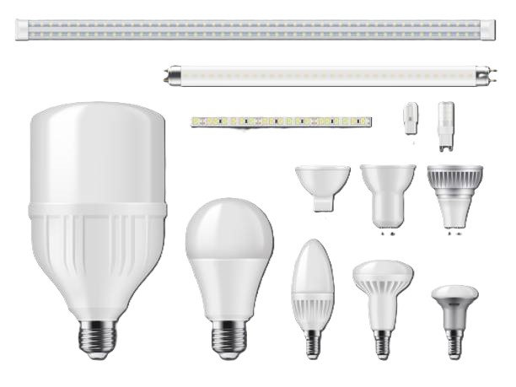

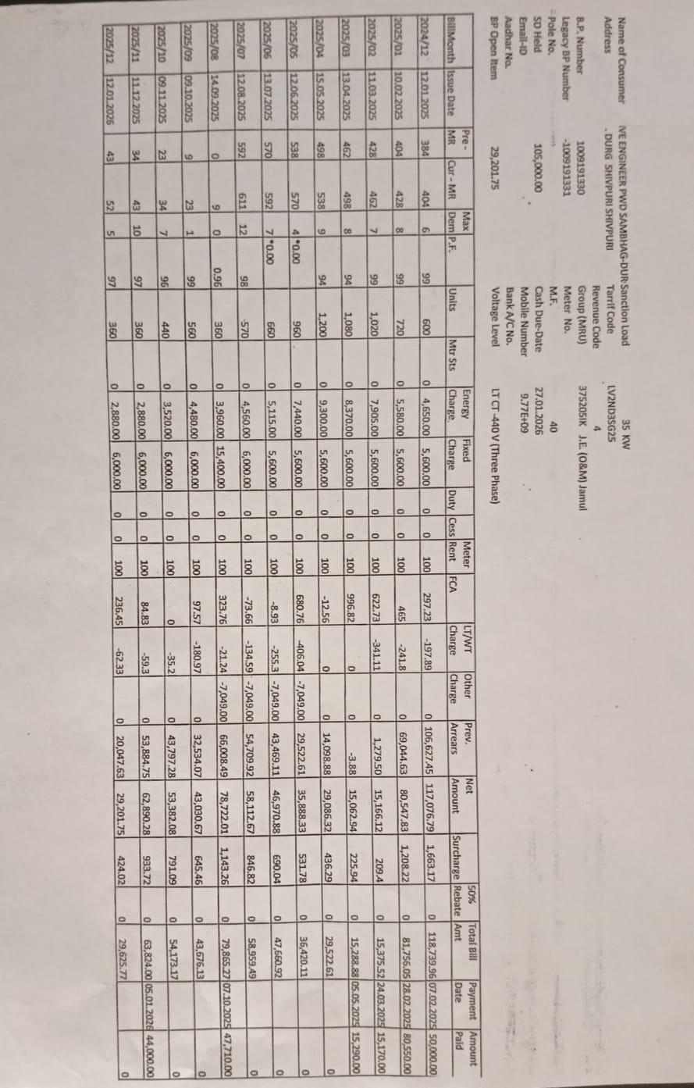
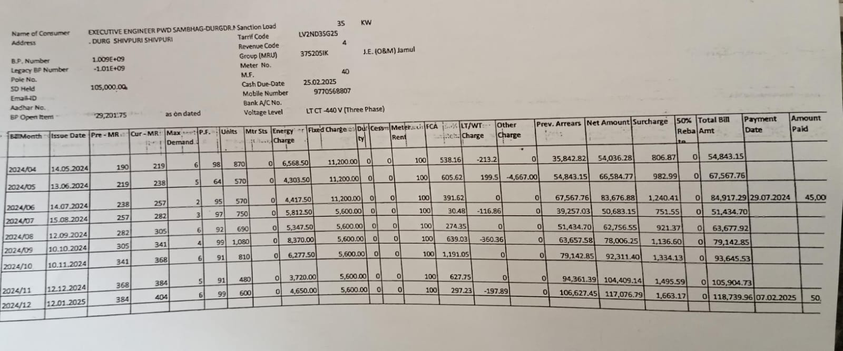

II. WATER AUDIT REPORT

1. Introduction
Water is the fundamental basis of life. Considering the increasing water crisis in the present time, conservation of water resources has become extremely essential. With this objective, a Water Audit was conducted at Dr. Manrakhan Lal Sahu Government College, Jamul to study the sources of water, consumption pattern, wastage, and possibilities for conservation within the college campus.

2. Objectives of the Water Audit
- To assess the total water consumption of the college.
- To identify the various sources of water supply.
- To analyse the causes of water wastage.
- To suggest suitable water conservation measures.
- To promote a Green Campus and sustainable development.

3. Profile of the Institution
- Name of the Institution: Dr. Manrakhan lal Sahu Government College, Jamul
- Location: Jamul, District Durg, Chhattisgarh
- Total Number of Students: Approximately 370
- Total Teaching & Non-Teaching Staff: 20 (13 Teaching + 7 Non-Teaching)
- Campus Area: 97,124.64 sq. meters (approximately 24 acres)
- Water Audit Period: Academic Session 2025–26

4. Sources of Water
S. No. | Water Source | Quantity | Status
1 | Municipal Water Supply | 0 | Not Available
2 | Borewell | 2 | 1 Working + 1 Non-Functional
3 | Water Storage Tanks | 4 | Working
4 | Rainwater Harvesting System | Yes | Needs Maintenance

5. Water Consumption Areas
S. No. | Area of Use | Details
1 | Toilets (Students & Staff) | 18 taps (boys), 18 taps (girls)
2 | Staff Area | 10 taps including basins and flush systems
3 | Drinking Water | 1 Water Cooler, 1 RO System
4 | Laboratories | 3 taps with basins
5 | Garden & Irrigation | 1 water tank (3000 liters), drip irrigation system
6 | Cleaning Work | 2 taps

6. Water Consumption Assessment
- Total Daily Water Consumption: Approximately 1000 Liters + 200 Liters for irrigation
- Per Capita Water Consumption: Approximately 2.7 Liters per person per day
- Major Water Consumption Areas: Toilets, cleaning activities, and irrigation

7. Causes of Water Wastage
- Leakage from some taps (approximately 10 flush and basin taps).
- Damaged service pipe used for irrigation, leading to water loss.
- Poor maintenance of flush systems (1 flush system not working properly).
- Occasional overflow of water tanks.
- Lack of awareness among users.

8. Rainwater Harvesting & Reuse
- Rainwater Harvesting System: Available.
- Roof-top Rainwater Collection: Stored and recharged into groundwater.
- Reuse of Water: Groundwater extracted through borewell is used for campus needs.

9. Suggestions for Water Conservation
- Immediate repair of leaking taps and pipelines.
- Installation of automatic/push-type taps.
- Adoption of dual-flush systems.
- Regular maintenance of the rainwater harvesting system.
- Organizing awareness programs for students and staff on water conservation.
- Regular testing of water quality (pH and other parameters).
- Installation of water-saving signboards, posters, and stickers near taps.

III. WASTE MANAGEMENT & E-WASTE MANAGEMENT AUDIT REPORT

1. General Information
- Name of the Institution: Dr. Manrakhan Lal Sahu Government College, Jamul
- Address: Jamul, District Durg, Chhattisgarh
- Type of Audit: Waste Management & E-Waste Management Audit
- Audit Period: Academic Session 2024–25
- Audit Date: 06/01/2026
- Audit Committee: Green Audit / Environmental Protection Committee
- Institution: Dr. Manrakhan Lal Sahu Government College, Jamul

2. Objectives of the Audit
- To identify and assess the types of waste and e-waste generated in the college.
- To review the system of waste collection, segregation, storage, and disposal.
- To evaluate the status of e-waste management in accordance with environmental regulations.
- To suggest measures for developing a clean and sustainable campus.

3. Types of Waste Generated

A. General Waste

(i) Wet Waste
- Food waste
- Garden/green area biodegradable waste
- Animal waste (cow dung)
(ii) Dry Waste
- Paper and cardboard
- Plastic and packaging material
- Metal and glass

B. E-Waste
- Obsolete computers, CPUs, monitors
- Printers, scanners, UPS
- Keyboards, mouse, cables, chargers
- Other electronic equipment

4. Existing Waste Management System
- Dustbins are available at various locations in the campus; however, they are insufficient in number.
- There is no proper segregation system for wet and dry waste.
- Cleaning staff are appointed regularly, but the workforce is inadequate.
- Wet waste is not utilized for composting or local disposal.
- Dry waste is not handed over to the municipal authority or any authorized local agency.

5. Existing E-Waste Management System
- E-waste is collected separately from general waste.
- Unusable electronic items are stored safely in a designated area.
- E-waste is not disposed of through authorized agencies as per government guidelines.
- No initiative has yet been taken regarding reuse or recycling possibilities of e-waste.

6. Findings
- Waste segregation practices are unsatisfactory.
- Proper labeling of dustbins is required at some locations.
- E-waste is being stored separately, but record maintenance is limited.
- There is a need to increase awareness about e-waste management among students and staff.

7. Recommendations
- Mandatory labeling of all dustbins with Green (Wet Waste) and Blue (Dry Waste) indicators.
- Establish and strengthen a composting unit for wet waste.
- Enter into an agreement with an authorized e-waste management agency for proper disposal.
- Maintain an annual e-waste record register.
- Organize awareness programs for students and staff on e-waste management.
- Promote reuse and recycling of old electronic equipment.
- Display waste segregation charts at prominent locations.
- Ensure proper maintenance of sanitary pad disposal machines.
- Form an Eco-Club to spread cleanliness and environmental awareness.
- Conduct regular cleanliness awareness competitions.
- Collect and manage plastic waste separately.
- Coordinate with the municipal authority for adequate dustbin arrangements.
IV. GREEN AUDIT
Objectives of the Green Audit
The main objectives of conducting a Green Audit are:
- To assess the environmental practices followed by the college.
- To promote efficient use of energy and water resources.
- To minimize waste generation and improve waste management.
- To enhance green cover on campus.
- To create environmental awareness among students and staff.
- To sustainable use of natural resources

- To enhance college profile

The scope of the Green Audit covers the following areas:
- Energy conservation practices
- Water usage and conservation
- Waste management system
- Green campus initiatives
- Carbon footprint and transport
- Environmental awareness activities
Methodology
The Green Audit was conducted using the following methods:
- Physical inspection of the campus.
- By Collection of data.
- Observation of waste segregation practices
- Review of institutional documents and records
- Survey of green initiatives undertaken by the college
Observations and Analysis
A. Green Campus Initiatives
- Regular tree plantation drives are conducted.
- The campus has gardens and lawns.
- Cleanliness drives are organized by NSS units.
- Posters promoting environmental protection are displayed.

PLANTATION -
To create Environmental awareness at the college campus we organize plantation program. We try to plant more trees, to keep the greeneries in the campus. Plantation program is organized every year with involving all students, principal, and all departments faculty members. In this session 13/07/2024 Ek Pad Ma Ke Nam programme was organized and about 100 ornamental, medicinal plant with beautiful trees was planted in the college campus. A plantation drive was organized on 22/07/24 and about 100 plants wear planted in the college campus. To keep the cleanliness and greeneries in the campus, NSS Students are serve in time to time. There are so many plants are present in our college campus categorized below-
Table 1: Approximate number of plants in College Campus
Category | Numbers (Approx.)
Herbs | 750
Shrubs | 452
Trees | 223
Medicinal Plant | 166

IDENTIFICATION OF PLANT SPECIES:
There are so many plant species are present at our college campus. The faculty member of the botany department audited and identified of Some plant species with the help of flora and google search.

Table 2 - List of the Plants Audited
S.No. | Scientific Plant | Local Name | Family | Uses | No.
 | Thuja compacta | Vidya patti | Cupressaceae | - Ornamental Indoor-Outdoor Plant | 153
 | Murraya paniculata | Madhukamini | Rutaceae | - Ornamental plants | 60
 | Eucalyptus  botryoides | Eukalyptous | Myrtaceae | - Antioxidants,  - anti-inflammatory | 15
 | Dalbergia sissoo | Shisham | Fabaceae | - fodder security | 32
 | Leucaena leucocephala | Subabul | Fabaceae | - Green manure and biomass production | 80
 | Bougainvillea glabra, | Paper flower | Nyctaginaceae | - Ornamental plants | 12
 | Hibiscus rosa-sinensis | Gudhal | Malvaceae | Ornamental plants | 26
 | Rosa indica | Rose | Rosaceae | Ornamental plants | 08
 | Nyctanthesarbo r-tristis | Harsingar | Oleaceae | Ornamental, Diabetic | 12
 | Plumeria alba | Temple Tree (Champa) | Apocynaceae | Ornamental | 01
 | Bauhania variegate | Kachnar | Ceasalpiniaceae | Avenue Ornamental Tree | 1
 | Bixa orellana | Sinduri | Bixaceae | Industrial Food | 2
 | Azadiracta indica | Neem | Meliaceae | Avenue Tree,Skin, | 15
 | Thevetia peruviana | Kaner | Apocynaceae | Ornamental, Aesthetic | 82
 | Plumeria alba | Temple Tree (Champa) | Apocynaceae | Ornamental | 3
 | Delonix regia | Gulmohar | Caesalpiniaceae | Avenue Tree, Ornamental | 35
 | Terminalia Catappa | Almond | Rosaceae | Source of Vitamin E | 02
 | Ixora coccinea | Ixora | Rubiaceae | Ornamental | 04
 | Chrysanthemumm indicum | Seventi | Asteraceae | Ornamental plants | 02
 | Calendula officinalis | Merigold | Asteraceae | Ornamental, diuretic and diaphoretic | 04
 | Pongamia pinnata | Karanj | Papilionaceae | Avenue, Insecticide | 03
 | Psidium guajava | Amrud | Myrtaceae | Fruit Edible,Source of Vitamin C, Fiber and antioxidents | 20
 | Mangifera indica | Aam | Anacardiaceae | Avenue Tree, Fruit Edible, Timber | 12
 | Ligustrum vulgare | Privet | Oleaceae | As hadge | 25
 | Capsicum annuum | Mirch | Solanaceae | Source of vit. C | 01
 | Saraca asoca | Ashok | Annonaceae | Avenue Tree | 12
 | Cycus revoluta | Cycus | Cycadaceae | Ornamental plants | 01
 | Codiaeum variegatum | Croton Plant | Euphorbiaceae | Ornamental plants | 03
 | Polypodiales encompasses | Fern |  | Ornamental plants | 22
 | Zizyphus jujube | Ber | Rhamnaceae | Fruit Edible, Fodder | 25
 | Neolamarckia cadamba | Kadam | Rubiaceae | Air Purification | 05

Table 3: Medicinal Plants

S.No. | Scientific Name of Plant | Local Name | Family | Uses | No.
 | Azadiracta indica | Neem | Meliaceae | Avenue Tree, Skin, | 25
 | Oscimum sanctum | Tulsi | Lamiaceae | Asthma, Bronchitis, Vomating, Malaria, Ring Worm | 38
 | Murraya koenigii | Mithi Neem | Rutaceae | anti-diabetic, antioxidant, antimicrobial, anti-inflammatory, | 01
 | Nyctanthesarbo  rtristis | Harsingar | Oleaceae | Ornamental, Diabetic | 22
 | Bryophyllum Pinnatum | Patherchatta | Crassulaceae | treating kidney stones, Wound and Burn Healing | 29
 | Carica papaya | Papaya | Caricaceae | abortifacient, a purgative | 03
 | Aloe vera | Ghikvar | Asphodelaceae | Antioxidant&antibacterial , managing blood sugar. | 14
 | Clitoria ternatea | Aparajita | Fabaceae | Panchakarma treatments, natural tonic for the blood | 02
 | Foeniculum vulgare | Sauf | Apiaceae | sattvic herb in ayurveda | 01
 | Calotropis Gigante | Aak | Apocynaceae | In ayurveda | 03
 | Syzygium cumini | Jamun | Myrtaceae | traditional Ayurvedic medicine | 38

Table 4: Type and quantity of flora
Particulars of Flora | Numbers
Full grown Tree | 323
Semi Grown Tree | 450
Quarter grown plants | 750
Grass Cover sqm | 4200 sqm

B. Carbon Footprint
A carbon footprint is the amount of greenhouse gases primarily carbon dioxide released into the atmosphere by an individual, event, organization, service, or product, expressed as carbon dioxide equivalent. In addition to the water, waste, energy and biodiversity audits we can also determine what our carbon footprint is, based on the amount of carbon emissions created. The release of carbon dioxide gas into the Earth’s atmosphere through human activities is commonly known as carbon emissions.
An important aspect of doing an audit is to be able to measure our impact so that we can determine better ways to manage the impact. In addition to the water, waste, energy and biodiversity audits we can also determine what our carbon footprint is, based on the amount of carbon emissions created.

The following activity is responsible for carbon emission: -
(a). Electricity purchased from Distribution companies.
(b). Transportation

(a). Carbon Emission by Electricity
Electricity is taken by grid which uses coal for generating electricity or DG set which uses diesel for electricity generation.
Table 5 : Carbon Emission by Electricity

Parameter | Emission Factor (A) | Unit in KWH  (B) | Total emission  (C= A x B)
Purchased Electricity | 0.82 | 9240 | 7576.80
Total Kg CO₂ Eq. Emission by Electricity |  |  | 7576.80
Thus, total emission by purchased electricity is 7576.80 Kg CO₂Eq.

(b)Carbon Emission by Transportation

Principal, teaching & non-teaching staff and student’s comes to college either by foot journey, two wheelers & four wheelers. The two major fuels used by the transport sector are petrol. These fuels are carbon intensive as they contain 80-85% of carbon by weight.
Table 6: Carbon emission by transport

S.  No. | Fuel Used | Types of Transport | Persons | No. of Persons | A | B | C | D= C/B | E | F=E x D | G | H=G x F x A
 |  |  |  |  | Nos. of Vehicle Used | mileage | Av. distance in KM | Fuel Consum ed per Day per Vehicle in ltr | Total working days | Petrol Consumption Per Vehicle in a year | Emission factor | Total emission
1 | No Fuel | foot journey  &  Bicycle | Students | 225 | - | -
1 | No Fuel | foot journey  &  Bicycle | Non-Teaching  Staff | 01 | - | -
2 | Petrol | Two-Wheeler | Students | 84 | 49 | 40 | 15 | 0.38 | 261 | 99.18 | 2.67 | 12975.7
2 | Petrol | Two-Wheeler | Non-Teaching  Staff | 05 | 05 | 40 | 09 | 0.23 | 261 | 60.03 | 2.67 | 801.40
2 | Petrol | Two-Wheeler | Teaching Staff | 04 | 04 | 40 | 18 | 0.45 | 261 | 117.45 | 2.67 | 1254.37
3 | Petrol | Four  Wheeler | Teaching Staff | 08 | 07 | 17 | 13 | 0.76 | 261 | 198.36 | 2.67 | 3707.35
Total CO₂ emission in KgCO₂ eq per Year |  |  |  |  |  |  |  |  |  |  |  | 18738.82
Thus, total emission by the transport is 18738.82 KG CO₂ eq. Per year

Table7: Total Carbon dioxide emission at Dr Manrakhan Lal Govt. College, Jamul Bhilai

Area | CO₂ eq. emission in KG
Electricity | 7576.80
Transport | 18738.82
Total | 26315.62

Reduction of Carbon Emission

Reduction of Carbon Emission due to absorption of CO₂ by Tree Plantation. Plantation is a great way to help sequester carbon emissions. Through photosynthesis trees absorb carbon dioxide to produce oxygen, food and wood.
Table 8: Carbon absorption by plantation.

Particulars of Flora | Numbers | Carbon absorption by one tree Per year | Total CO2 in Kg
Full grown Tree | 323 | 6.8 | 2196.40
Semi Grown Tree | 450 | 3.4 | 1530.00
Quarter grown plants | 750 | 1.7 | 1275.00
Total CO2 absorption by trees |  |  | 5001.40

Thus Total Reduction in CO₂emission at Dr Manrakhan Lal Govt. College, Jamul Bhilai Campus 5001.40. Which is only approx. 20 % of the total CO₂ emission. About 27000 plants were planted in our college by the ICICI foundation there, but only 5% of them survived, hence it is not only important to plant trees but also to keep them alive and grow them is the biggest responsibility, in which direction should efforts be made.
RECOMMENDATIONS

- College should initiate a practice where all guests should be given a planter as a gift rather than a bouquet of flowers.

- Constitution of Eco club

- Organize Environmental Awareness programmes

Conclusion
The Green Audit reveals that the college is committed to maintaining an eco-friendly campus. While several initiatives have already been implemented, there is scope for improvement through better use of renewable energy, enhanced water conservation, and increased student participation. Continuous monitoring and periodic audits will help the institution achieve sustainable development goals and improve its environmental performance.
The Energy Audit indicates that the institution is conscious of energy conservation and sustainability. With the implementation of recommended measures, the college can further improve its energy efficiency and align itself with NAAC’s vision of a green and sustainable campus.
The Water Audit reveals that there is significant potential for water conservation at Dr. Manrakhan Lal Sahu Government College, Jamul. By effectively implementing the suggested measures, water wastage can be minimized and the institution can be developed as a Green Campus promoting sustainability.
The Waste Management and E-Waste Management practices at Dr. Manrakhan Lal Sahu Government College, Jamul are found to be satisfactory and environmentally conscious. However, by implementing the suggested corrective measures, the institution can further strengthen its position as a clean, green, and sustainable campus.



Submitted By
Dr. Ramesh Meshram
Shri Gajendra Kashyap
Dr. Rachana Choudhary
Miyawaki Plantation
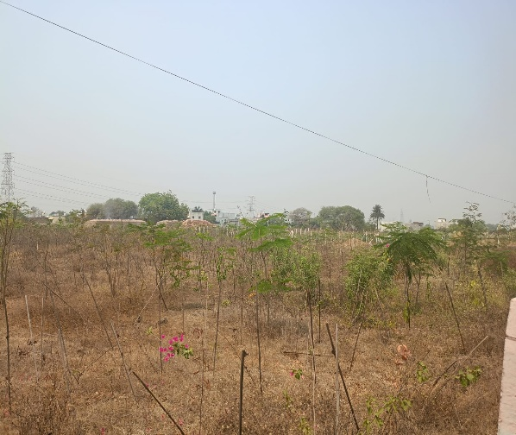
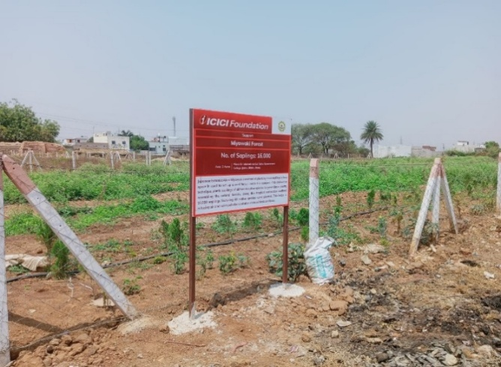

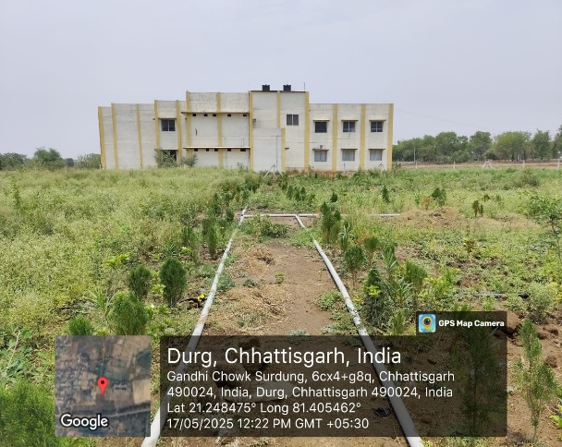
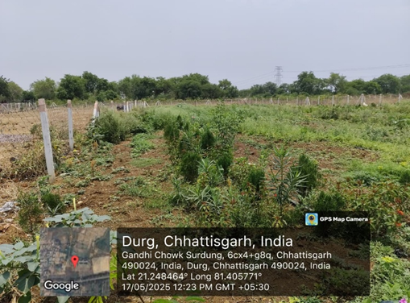

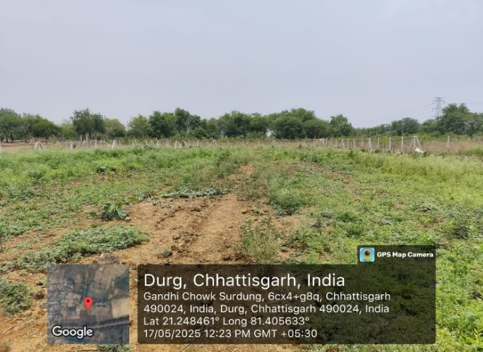

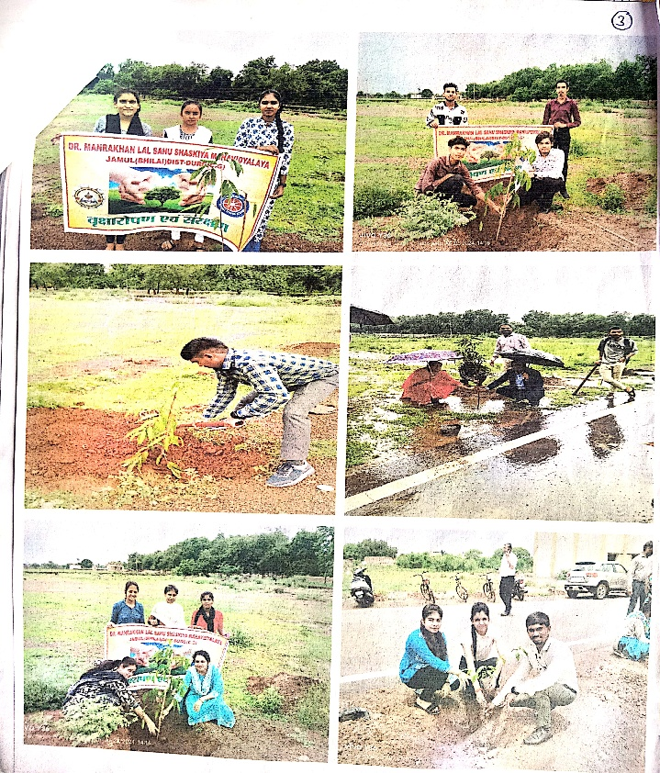
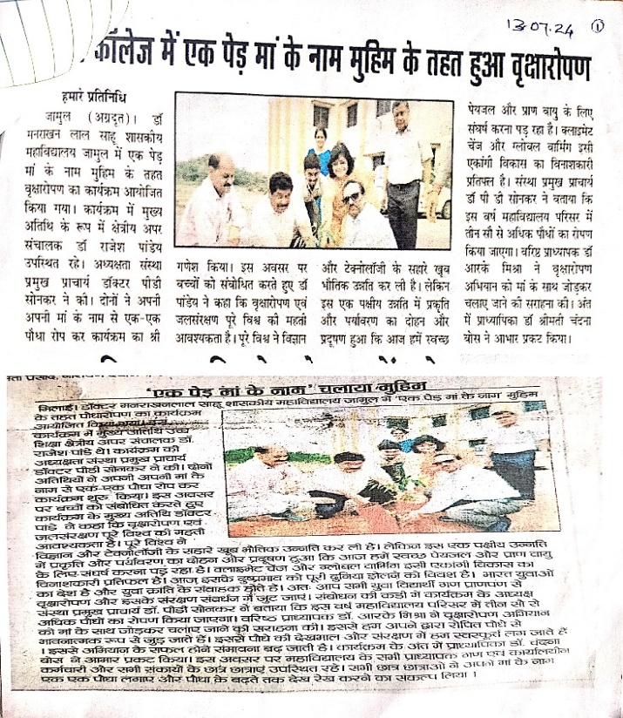
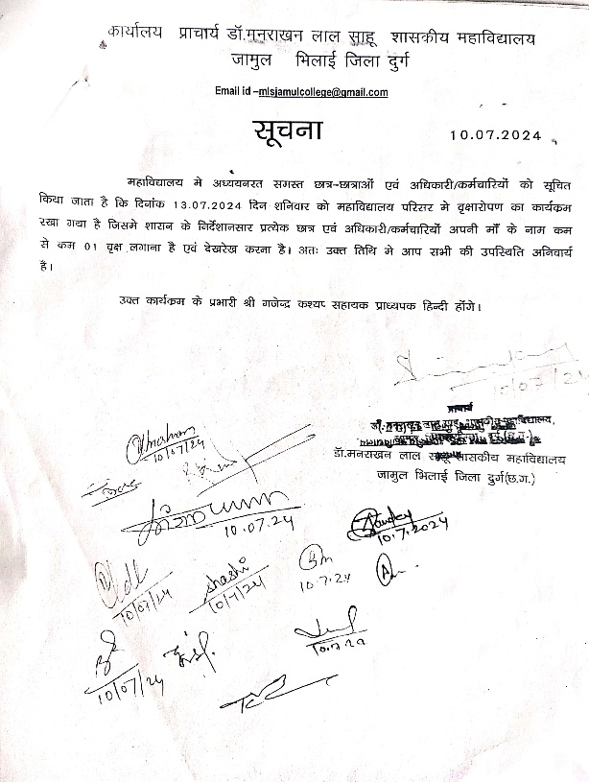
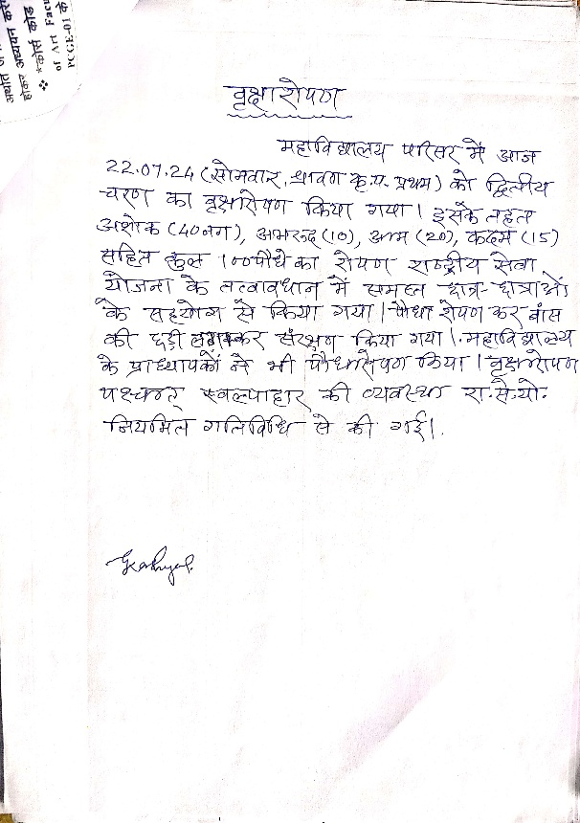
Plantation Drive

